Date : 15 /01 /2020

**PRACTICAL NO: 7**

**AIM:** Session impersonation **using Firefox and Tamper data add-on.**

**A] Session impersonation**:

STEPS:

1. Open firefox.

2. Go to tools 🡪 Addons 🡪 Extension

3. Search and install EditThisCookie or Cookie import/Export or any Cookie tool.

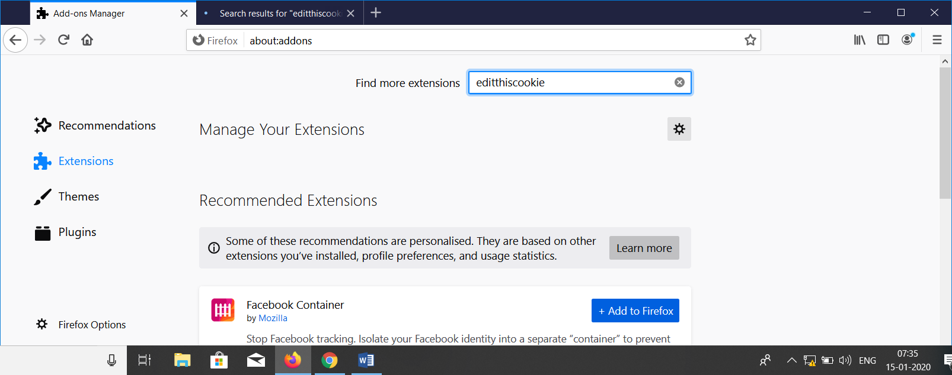

Q.What is EditThisCookie Tool?

“EditThisCookie” is a cookie manager. You can add, delete, edit, search, protect

and block cookies!

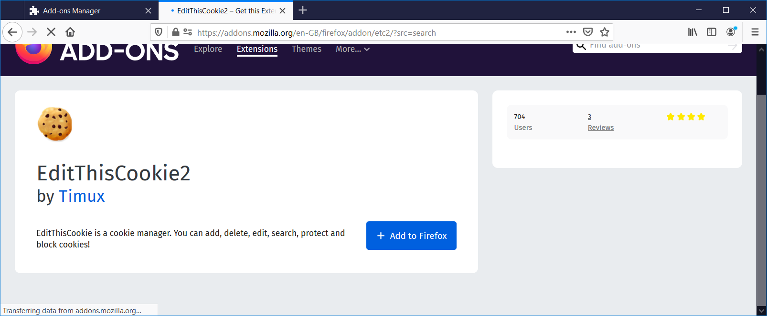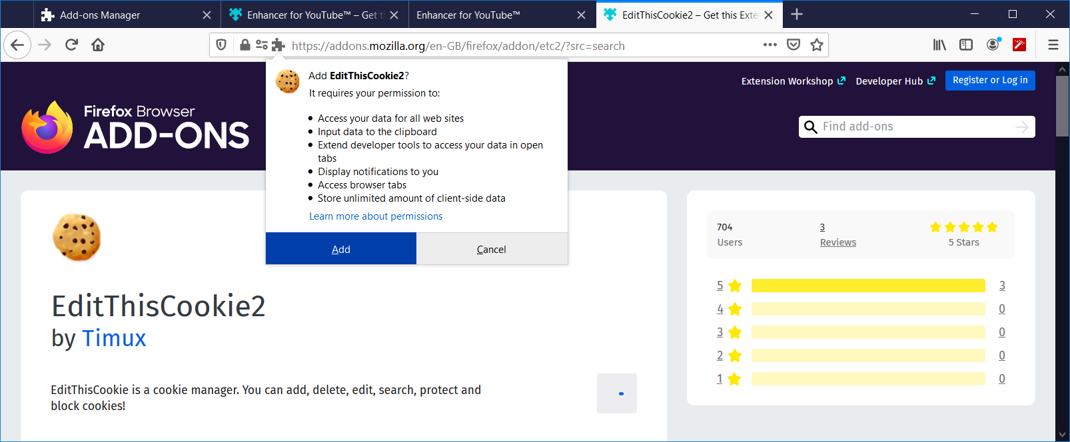 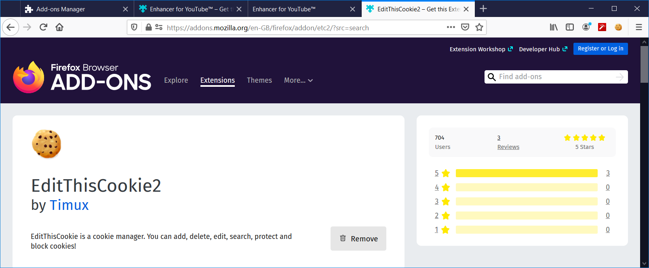

4. Now click on Cookie logo &gt;Click on export arrow &gt; Cookies copied to the

clipboard. 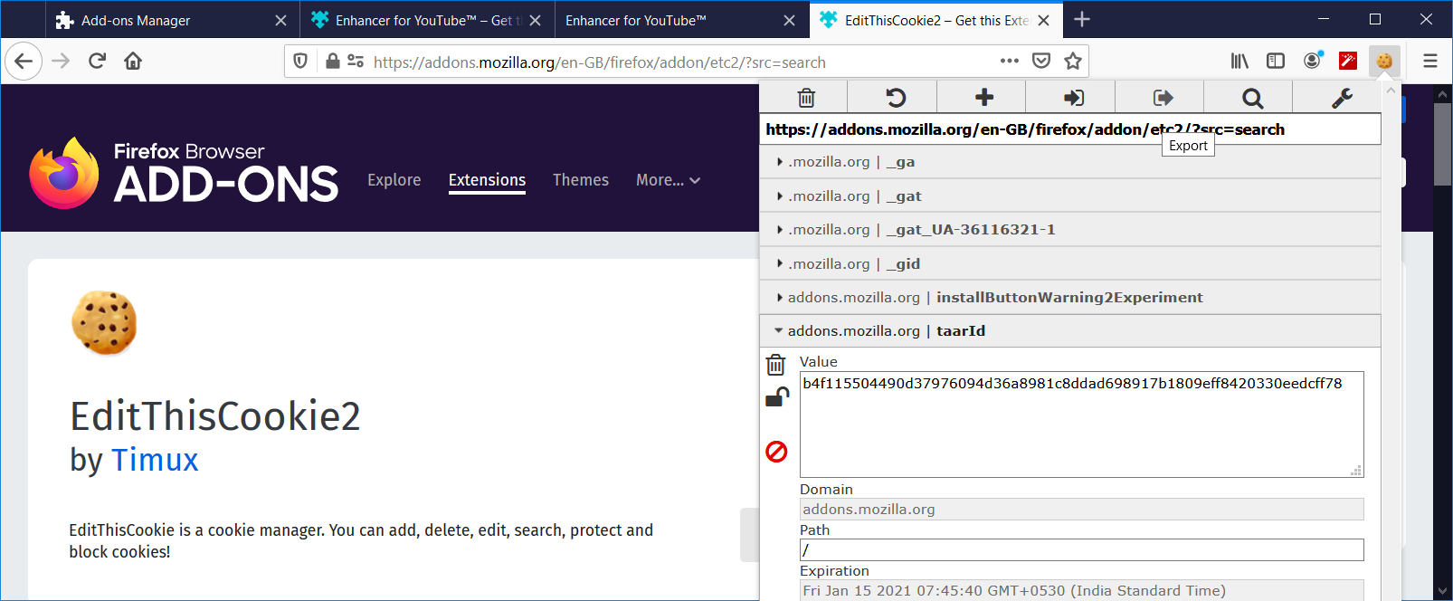

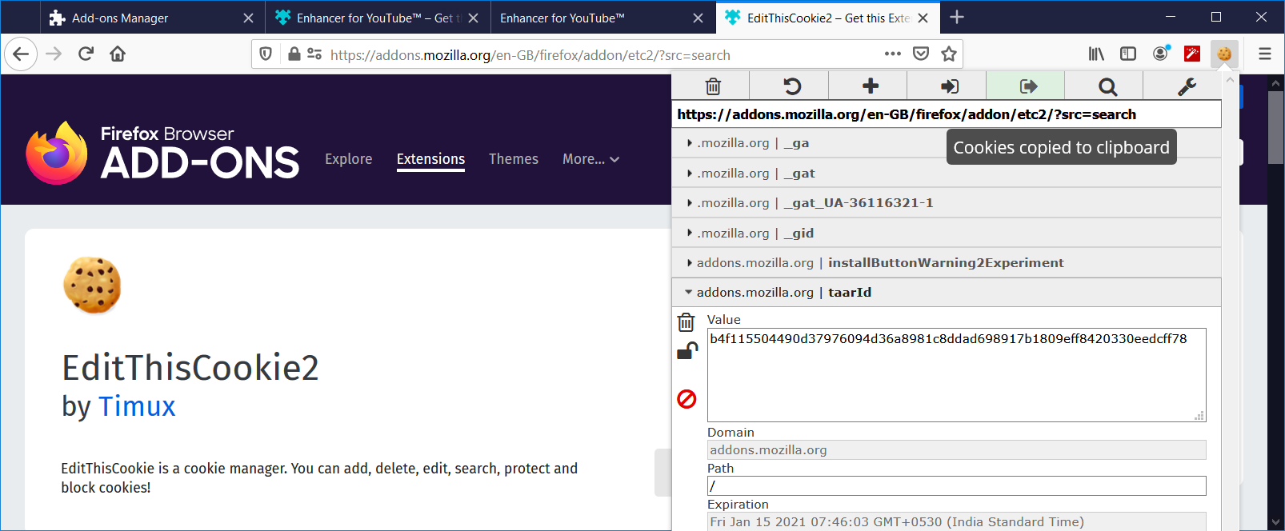

Logout from the webpage once the cookie got exported.

5. Now open notepad🡪 Paste the cookie in the notepad. You can see all the

information in the form of cookie.

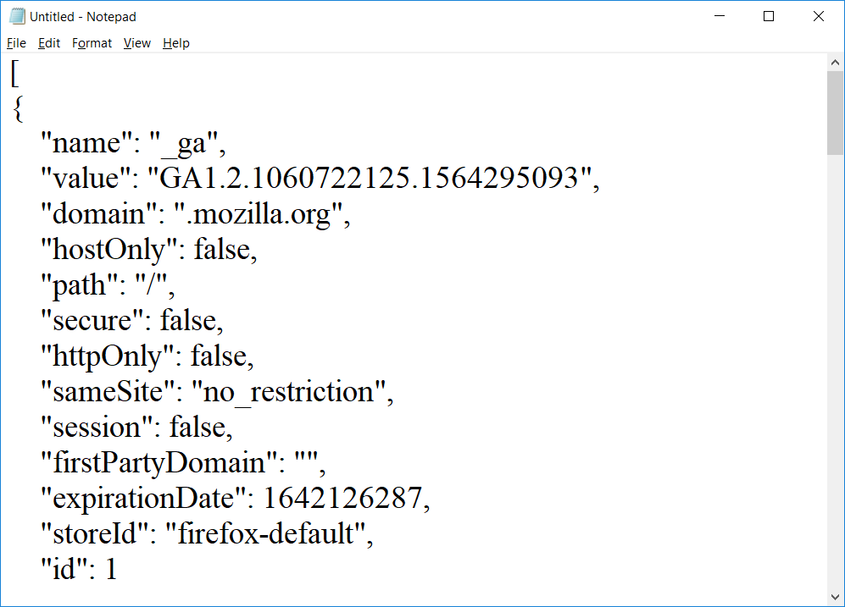

**B] Tamper Data add-on :**

1. Open Firefox.

2. Go to tools 🡪 Addons 🡪 Extension.

3. Search and install Tamper Data.

Q. What is Tamper Data?

“Tamper Data” is an add-on for Firefox that lets you view and modify HTTP

requests before they are sent. It shows what information the web browser is

sending on your behalf, such as cookies and hidden form fields.

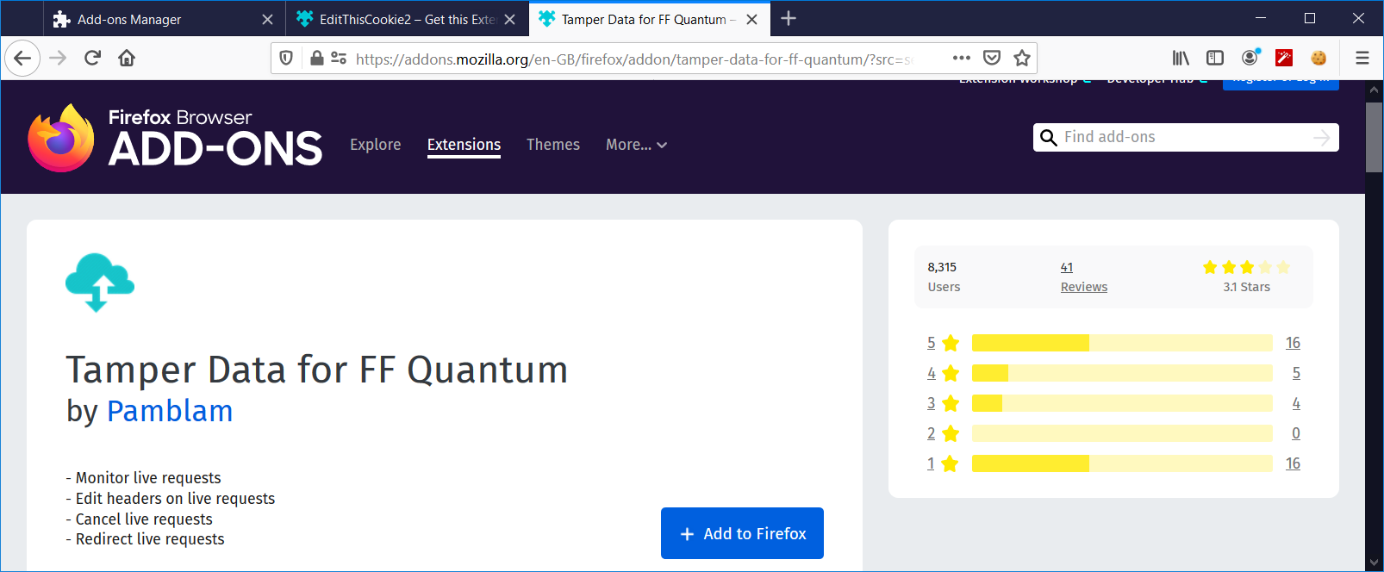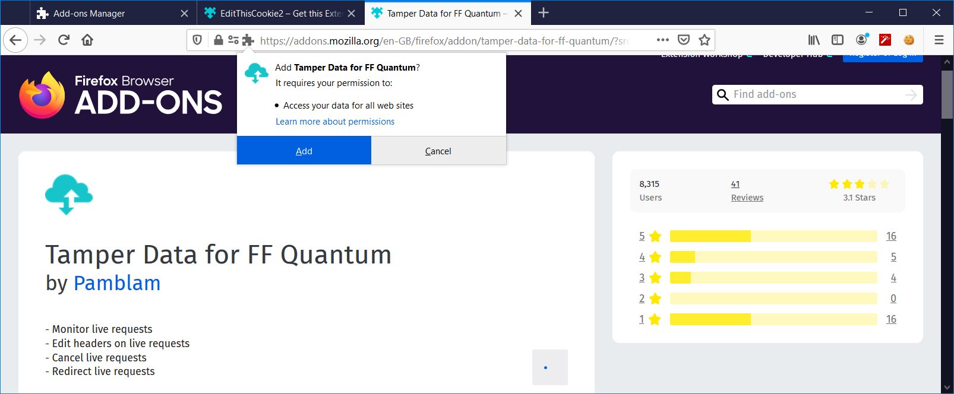 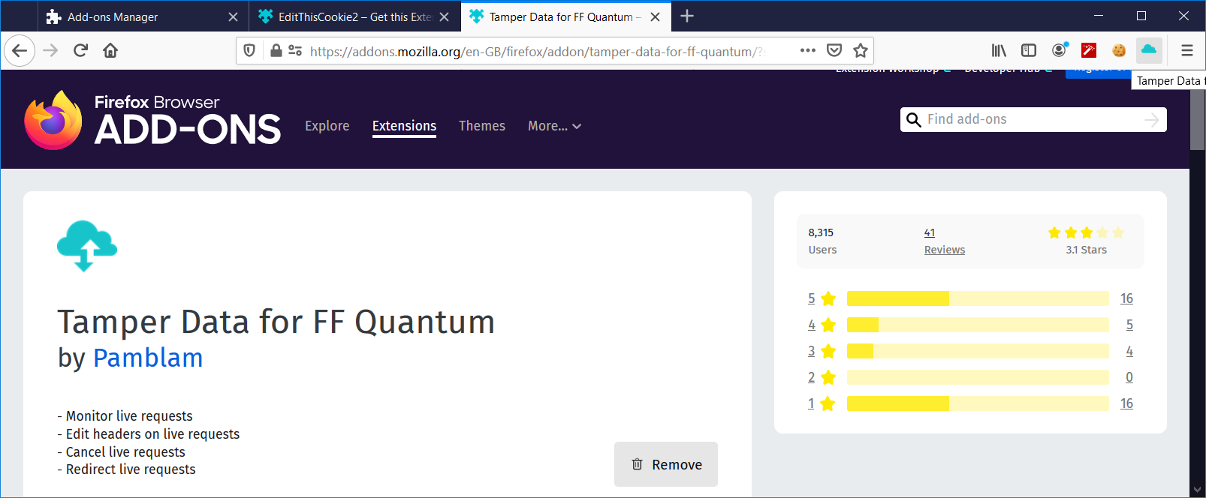

4. Select a website for tampering data(eg.razorba) .

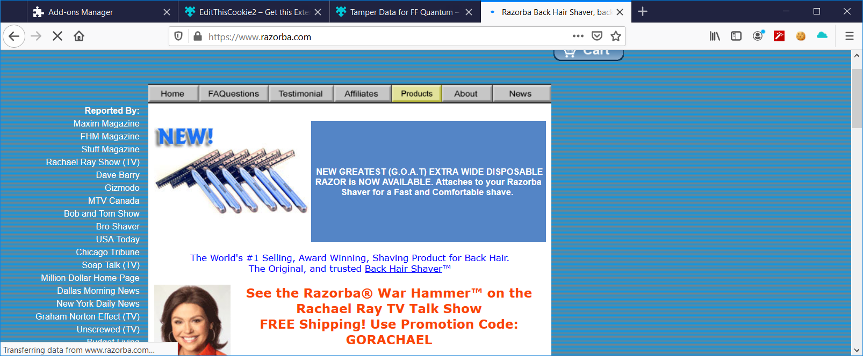

5. Then select any item.

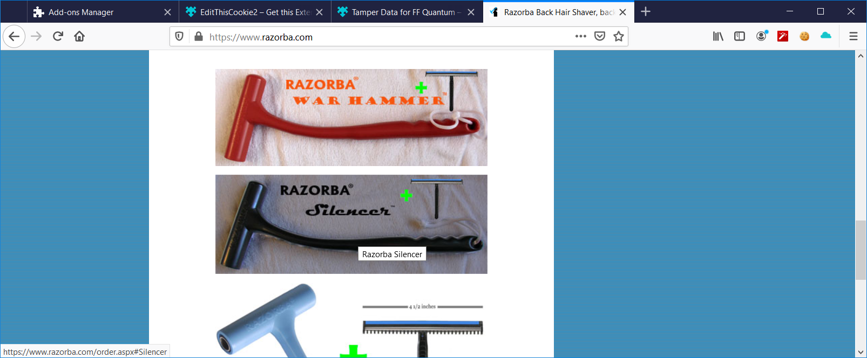

6. “Start” tamper data .

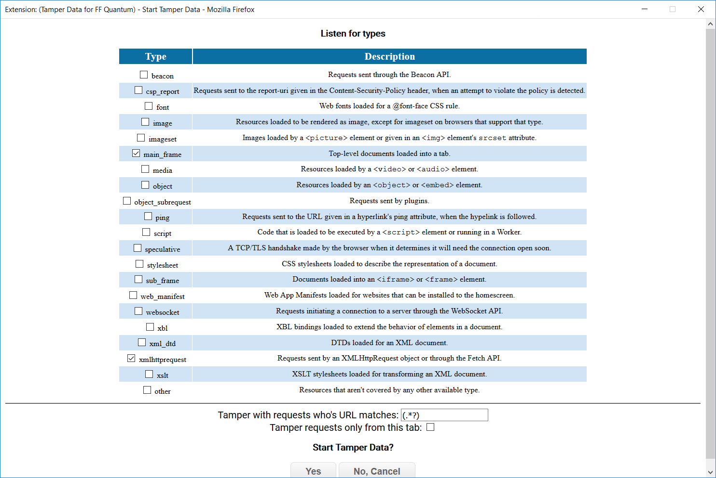

7. Then click on “add to cart” for selected product.

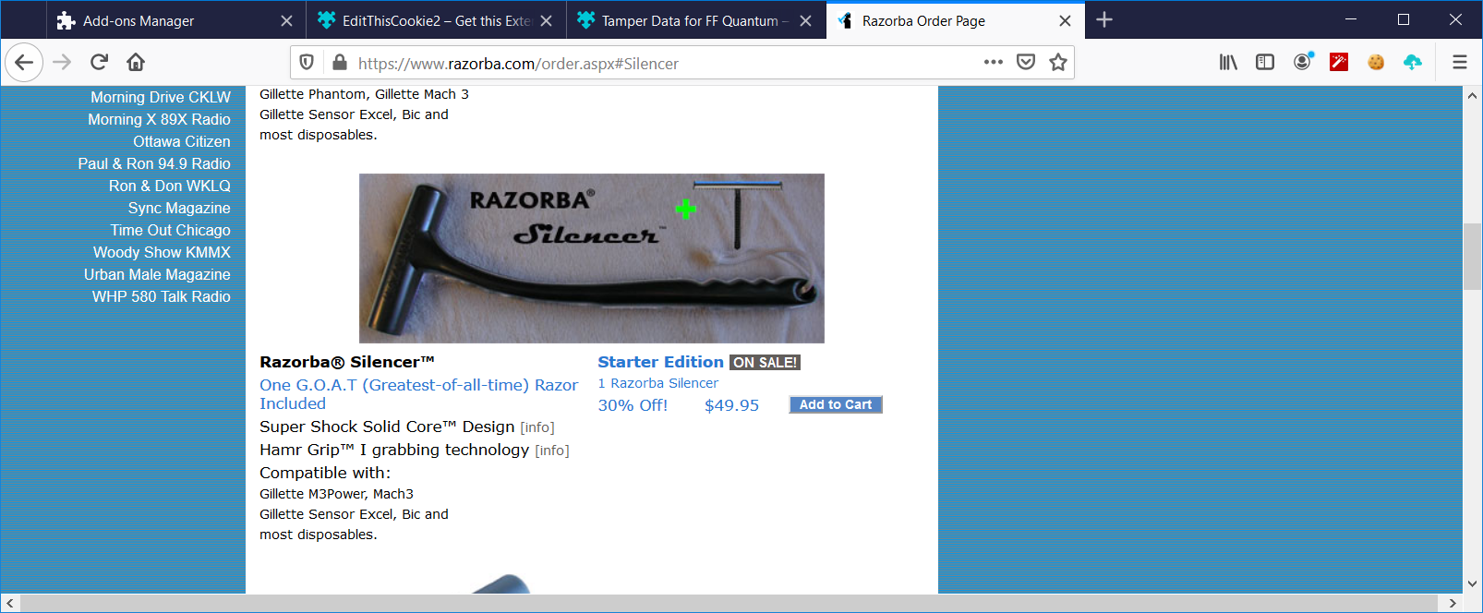

8.click on ok🡪ok🡪ok until we see the option for ”proceed to checkout” for further

process.

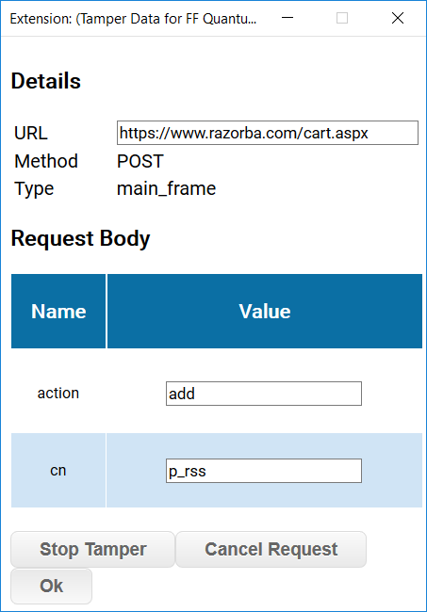

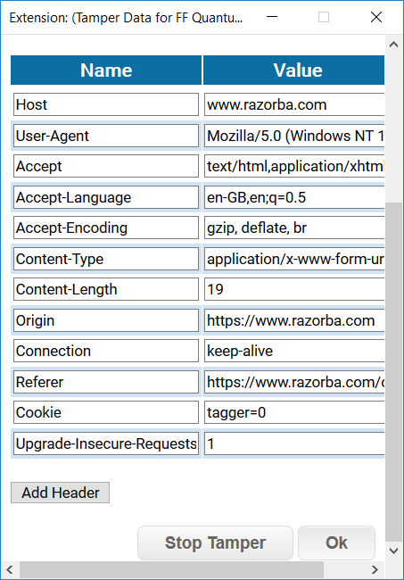

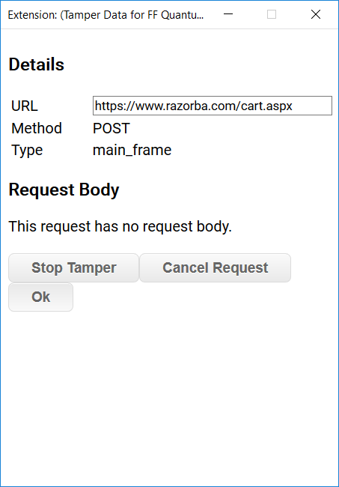

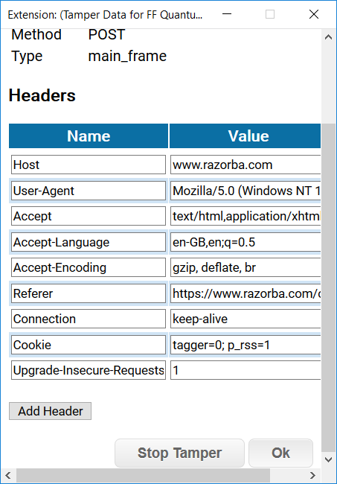

9.Now click on “Proceed to checkout”.

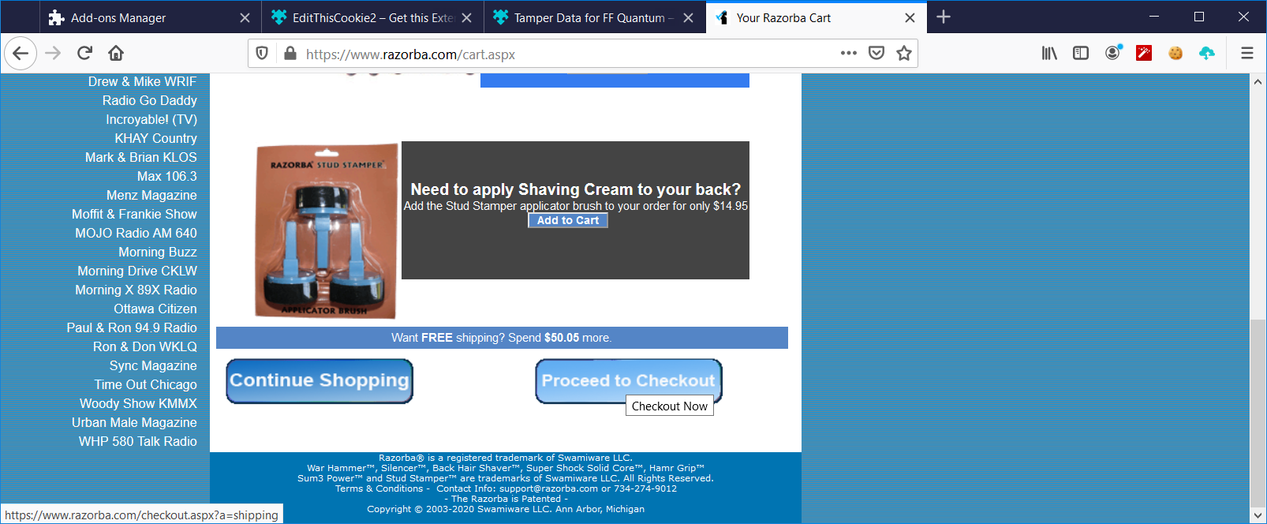.

10. Now click on “oneday” option.

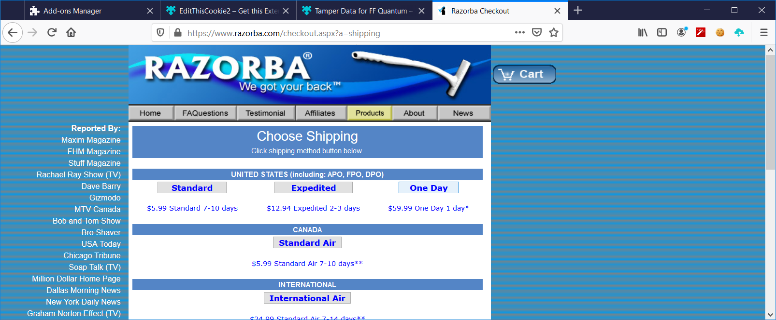

Click on ok until we get the next option “PayPal”.

11. Now click on option “PayPal”.

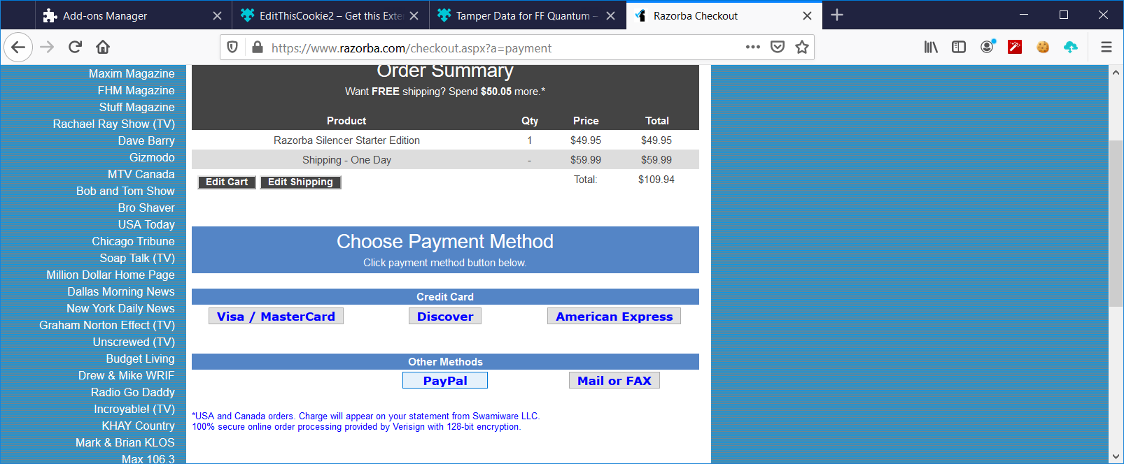

Click on ok until we get the final output .

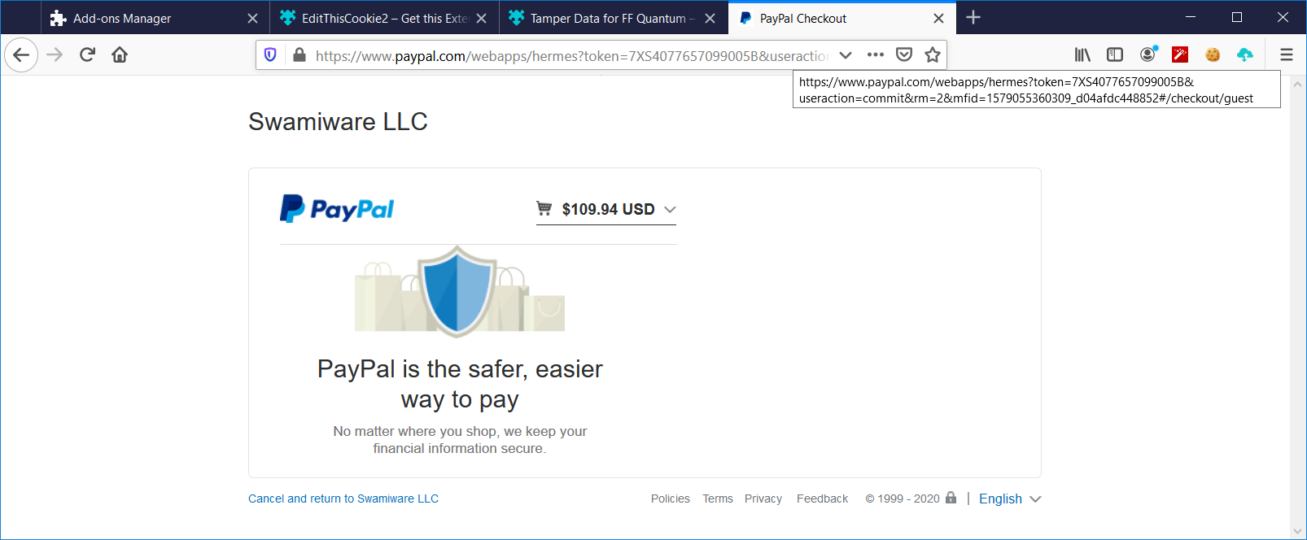

**C] Tamper Data add-on :**

1. Open Firefox .

2. Go to tools 🡪 Addons 🡪 Extension .

3. Search and install Tamper Data .

Now search any website for login(eg.vivacollege.com)

4. After visiting the website 🡪 start tamper data .

5. Sign into the website by entering “username” and “password”.

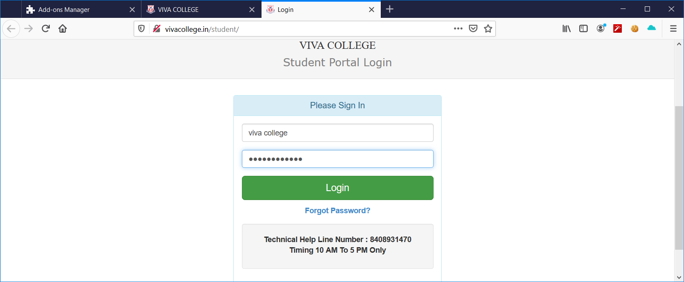

7. The output will be as follows. Attacker can see the unencrypted data of the user

i.e username and password.

